**USABILITY STUDY OF PARENT CONTROL APP; NORTON FAMILY**

## **ABSTRACT**

Internet Access is crucial for all age groups in the current scenario. However, for teens and younger ones, there is the requirement of monitoring what they are accessing and what they are exposed to, on the internet. Because there seems infinitive inappropriate stuff like violence, self-harming, etc.

Both Android and iOS play-store have parental control apps and Apart from these apps, Android and Apple themselves have provided built-in features for Parental Control. However the targeted group (parents) doesn't seem much interested in using such apps and features. Several researches have been conducted to find out the reasons behind this gap of being aware of the apps but still considering these useless.

Following is the work that we have done to find out the causes behind the scenario discussed above. It consists of a questioning session and an experiment about an Android app for parental control, Norton Family. Based on the results of the evaluation, the conclusion is included along with some recommendations.

## **KEYWORDS**

Usability, Usability testing, Parental Control Apps, Social Media, Web Content.

**INTRODUCTION**

None can deny the fact that capabilities of individuals vary from person to person for different reasons, like personal intellect and demography. This difference gets much bigger when it comes to use of technology.

Statistics reveal that about 93% of Millennials own a smartphone. This is such a percentage when only 76% of Generation X(age 30 or above) are smartphone users. It means about 17% Millennials are those who have been using Smartphone while their parents are totally unaware of what they are doing and can possibly do on their phones.

According to research conducted by the Pew Research Center, 61% of parents of teens visualize what websites their children visit. These are the statistics that are made about the Western world. Asian countries especially the sub-continent is far behind this level. Only 12% of Pakistanis with age 30-41 are using smartphones. And certainly, very little number is using Parental Control Apps.

Apart from monitoring, another important issue is that parents are unable to restrict their children for excessive use of such technologies. They find it hard to implement restrictions through applications that seems to be usability issue. We have conducted an examination to find out what are the issues that are encountered by them while using the app providing Parental Control.

We have chosen the ‘Norton Family’ app for the research which is listed among the top 10 Parental Control Apps. It is designed to let the kids explore web or internet world more safely. The app checks the child’s devices in the light of rules defined by the parents.

## **PREVIOUS STUDY**

Various studies are done in order to find out the perspective of parents about the Parental Control Applications. Some of these studies aim to increase the awareness about the effectiveness of such apps while some are done with the intent to identify the difficulties that parents might face while using these apps or features.

We found research done in Indonesia in which they have tried to assess the feature on the basis of four aspects i.e. Safety, Effectiveness, productivity, and satisfaction. Out of all aspects, effectiveness got the highest value after the assessment with the score (0.3652) which clears out that the subject did find application useful regardless of few difficulties faced during the experiment. However, the research is concluded with a question mark that monitoring internet surfing of children increases the annoyance in children as they get irritated to see blocked content while surfing on the internet which can mark negative impacts on psychology of children.

## **PURPOSE OF STUDY**

The statistics discussed above reveal that the guardians and parents in the region(Subcontinent) are less aware of such surveillance. And those who are aware don’t find it easy in use. The following research will give their perspective about usability of Parental Control Android App, the Norton Family. Main focus is to find out how much time parents need to set up the required monitoring and what is the most difficult part in it for them.

The research has focused to prove following hypothesis:

* Parents are familiar with the Parental Control Apps.
* Parents found Norton Family app, learnable and engaging.
* Parents recommend the app to their fellows for its effectiveness.

## **EXPERIMENT DESIGN**

* Parents are asked to fill up the form regarding their required personal information first.
* They are provided a task set including primary task relating to Parental Control.
* Duration for completion of task set is recorded along with the difficulties faced by them while setting up monitoring.
* After completion of task set, parents are asked to answer the post usability test questionnaire.

It’s pertinent to note that parents were not provided with any kind of assistance during the experiment to prevent the experiment from pseudo results.

## 

## **PARTICIPANTS**

|  |  |
| --- | --- |
| Number of Participants | 35 |
| Gender | Male: 18,  Female:17 |
| Age | 20-35 ,35-50 |
| Familiarity with Parental Control | 70% |

## **MEASUREMENTS**

Based on the responses obtained from participants of research, following are the stats relating to measurements of experiments:

|  |  |
| --- | --- |
| **Task** | **Average Time** |
| Installation of Application on mobile | 1 minutes |
| Sign up as a Parent | 1 minutes |
| Sign in | 0.5 minute |
| Installation of app on child device | 2 minutes |
| Adding a child | 1.5 minutes |
| Setting up rules on child’ device | 3.5 minutes |

Few exceptional cases were observed for the above measurements with those parents who aren’t frequent mobile users. For example, the highest value for setting up rules on child device was 6 minutes and highest value for signing in was 2 minutes. It’s important to note that this delay was partially because of slower connectivity and partially because of reason given mentioned above.

## **EVALUATION**

Questions from Mobile Application Usability Questionnaire(MPUQ) were selected to find out the user experience of Norton Family App. Questionnaire is focused on finding out the Ease of use and learning. Majority of the parents have given positive feedback while some have provided the negative one.

|  |  |  |  |
| --- | --- | --- | --- |
| Question | Positive Feedback | Negative Feedback | Uncertain |
| Is it easy to learn to operate this product? | 80% | 5.7% | 20% |
| Is using this product sufficiently easy? | 60% | 11.4% | 28.6% |
| Have the user needs regarding this product been sufficiently taken into consideration? | 68.6% | 8.6% | 22.9% |
| Are the operation of this product simple and uncomplicated? | 48.6% | 14.3% | 37.1% |
| Is it easy to access the information that you need from the product? | 60% | 8.6 | 31.4% |
| Are the characters on the screen easy to read? | 91.4% | 8.6% |  |
| Are the command names meaningful? | 88.6% | 11.4% |  |
| Has the product at some time stopped unexpectedly? | 83.3% | 16.7% |  |
| Is the amount of information displayed on the screen adequate? | 74.3% | 25.7% |  |
| Is the product reliable, dependable, and trustworthy? | 60% | 2.9% | 37.3% |
| Is the way product works overall consistent | 66.7% | 33.3% |  |
| Is it sufficiently easy to operate keys with one hand? | 86.7% | 13.3% |  |
| Is the organization of the menus sufficiently logical? | 95.4% | 4.6% |  |
| Are the HOME and MENU buttons sufficiently easy to locate for all operations? | 97.1% | 2.9% |  |

## **OVERALL FEEDBACK:**

### Majority of users, at first, found the application difficult to operate, but they have given positive feedback after completion of the experiment. This is surely because they found the features meaningful and helpful for them. Average rating was ‘4’ out of 5, for the application.

### **User Experience:**

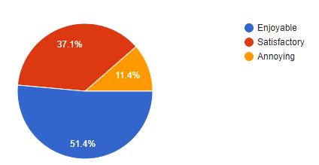

### 

### 

### **Rating:**

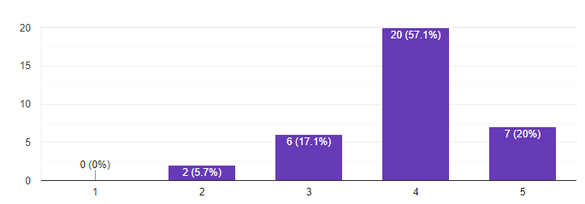

Recommendation from Parents:

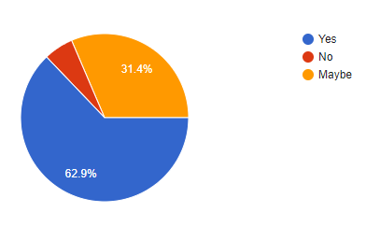

## **RESULTS AND DISCUSSION**

Those who are not frequent user of Android phones faced a lot more difficulties in completion of task set than those who are frequent users. Overall, parents found it useful and have given positive feedback. An unexpected issue in the app was noticed that children were getting restricted even before listing parent device on child device. Few child devices got locked without any definition of house rules on device.

Majority of parents applied the parental control for the first time and they found it just crucial for their teens monitoring. They found it useful but had to ultimately uninstall the app because of anxiety noticed in the children. Some of them refused to use the app because of continuous interruption and increased complications due to the app in smartphone usage.

Let’s have a look at the results of hypothesis provided in the beginning of this research(in purpose of study)

* About 70% of participants were familiar with the Parental control feature(not with the Norton Family).
* More than 50% found the app effective and user experience enjoyable.

Majority of parents said that they will recommend the app to their fellows.

**RECOMMENDATIONS**

What we found is that teenagers are much more well informed about the mobile usage than the parents. Teens usually get the whole access to mobile phones and internet at very early age due to which they become undefeatable for parents. They do have access even to their parents mobile phones through which they were able to make changes in the house rules defined with the help of Norton Family app.

The complications in the application are quite more than the need. The restrictions on child’ device should be in a way that they don’t get into anxiety. This can be done by diverging the child to appropriate site rather than continuously bothering with same message of ‘site restricted’. Also the app vendor should give hourly basis reports by notifying parents so that they don’t have to go to the app of email for accessing the reports of their child.

**References**

-Ambarsari, Erlin Windia & Herlinda, Herlinda & GS, Achmad & Prasetya, Rendi & Herfina, Herfina. (2018). Usability of Parental Control Application Features To Protect Children From Negative Internet Impact By Using MAGIQ Approach (Case Study In Indonesia). 10.4108/eai.24-10-2018.2280591.

-Alelyani, Turki & Ghosh, Arup & Moralez, Larry & Guha, Shion & Wisniewski, Pamela. (2019). Examining Parent Versus Child Reviews of Parental Control Apps on Google Play. 10.1007/978-3-030-21905-5_1.

-Qayyum, Sehar & Rafiq, Samiya. (2016). Website Design Usability Issues Faced by the User in Pakistan. http://iiste.org/Journals/index.php/CEIS/article/view/32859/33756. 7. 2222-2863.